- Eat a serving of both fruits and vegetables, with every meal of the day, at least 3 times a week for the month of October 2015.

- Complete the “Spooktacular 30 Day Total Body Challenge” for the month of October 2015
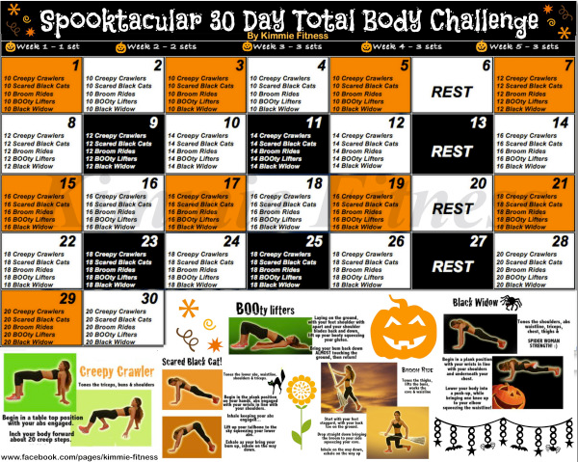
If you have any questions or concerns regarding the challenges, please feel free to schedule a time to talk with me. I want to help you meet these challenges!

