- Complete the 30 Day Squat Challenge, either the “Beginner” or “Advanced” option:

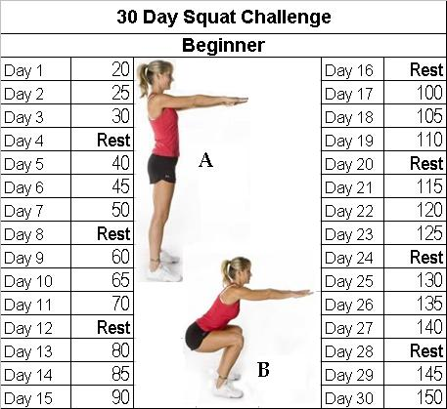

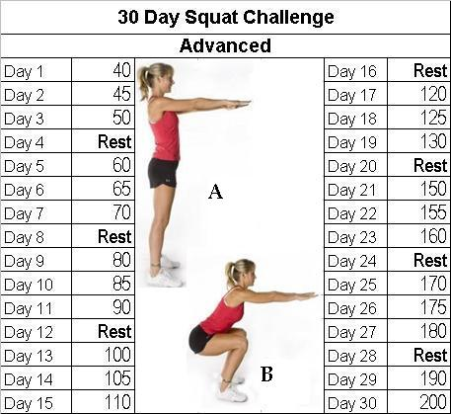

- Eliminate fast-food eating for the entire month of June 2015

If you have any questions or concerns regarding the challenges, please feel free to schedule a time to talk with me. I want to help you meet these challenges!

