- Complete a daily water challenge at least 3 times a week according to weight:
Weight Ounces of Water Daily
100 pounds 67 ounces
110 pounds 74 ounces
120 pounds 80 ounces
130 pounds 87 ounces
140 pounds 94 ounces
150 pounds 100 ounces
160 pounds 107 ounces
170 pounds 114 ounces
180 pounds 121 ounces
190 pounds 127 ounces
200 pounds 134 ounces
210 pounds 141 ounces
220 pounds 148 ounces
230 pounds 154 ounces
240 pounds 161 ounces
250 pounds 168 ounces
- Complete the 30 day Thigh Challenge:
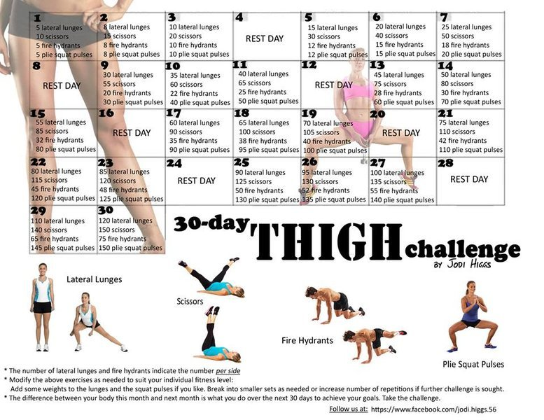

If you have any questions or concerns regarding the challenges, please feel free to schedule a time to talk with me. I want to help you meet these challenges!

