- Complete the 30 Day Guns, Buns, & Ab Challenge

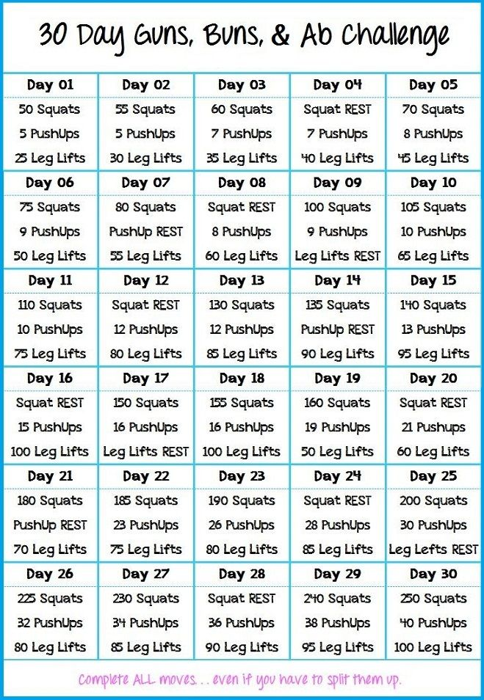

- Try a new healthy recipe at least once a week for the month of July 2015. www.skinnytaste.com has some yummy but healthy ideas : )

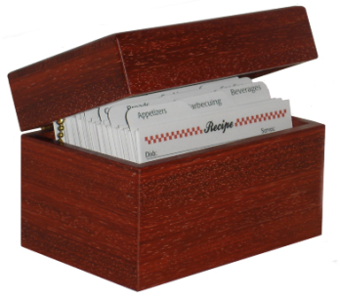

If you have any questions or concerns regarding the challenges, please feel free to schedule a time to talk with me. I want to help you meet these challenges!

