- Complete the February 28 Day Challenge:
- Eat at least 1 “Heart Healthy Foods” for breakfast, lunch, and supper, at least 3X a week:

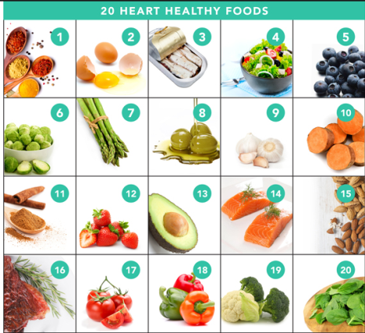

Please let me know if you have any questions or concerns regarding the challenges, the goal is for all to be successful!!!

