- Complete the 30-Day Plank Challenge:

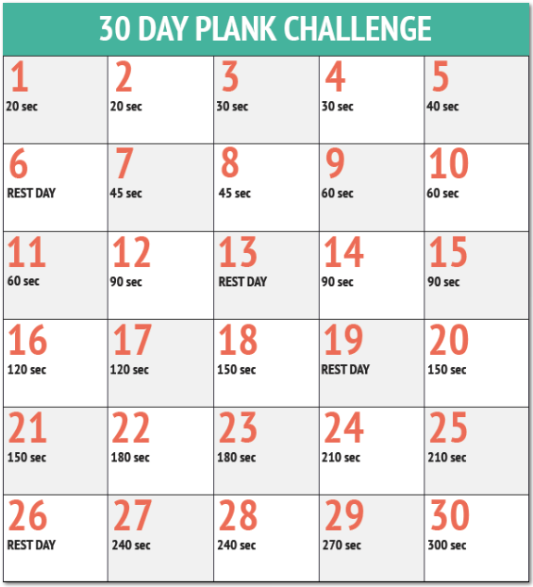

- Eliminate eating/cooking fried food for the entire month of September. Bake, grill, or boil only!!!
NO

If you have any questions or concerns regarding the challenges, please feel free to schedule a time to talk with me. I want to help you meet these challenges!

